Twin Cities    A unique memory that lasts all year |  | Twin Cities  A unique memory that lasts all year
    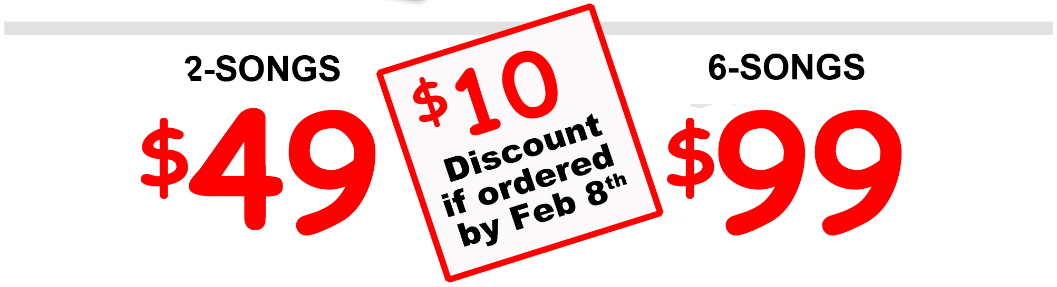 | Male or Female Quartet  A Cappella Love Songs  At workplace, home, school,  restaurant, senior residence,  hospital, or your choice.  www.sing4me.net  612-470-8540
  ...4-hour window
  Small additional charge for shorter delivery windows.
  Virtual deliveries & Custom packages available.
  Brought to you by Twin Cities area barbershop choruses since 1980.
  Seller’s chapter & contact info:
  Male or Female Quartet
  A Cappella Love Songs
  At workplace, home, school,
  restaurant, senior residence,
  hospital, or your choice.
  www.sing4me.net
  612-470-8540
  ...4-hour window
  Small additional charge for shorter delivery windows.
  Virtual deliveries & Custom packages available.
  Brought to you by Twin Cities area barbershop choruses since 1980.
  Seller’s chapter & contact info:

